防雨罩使用说明书
Waterproof Cover Manual
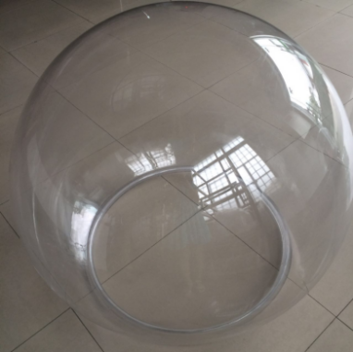
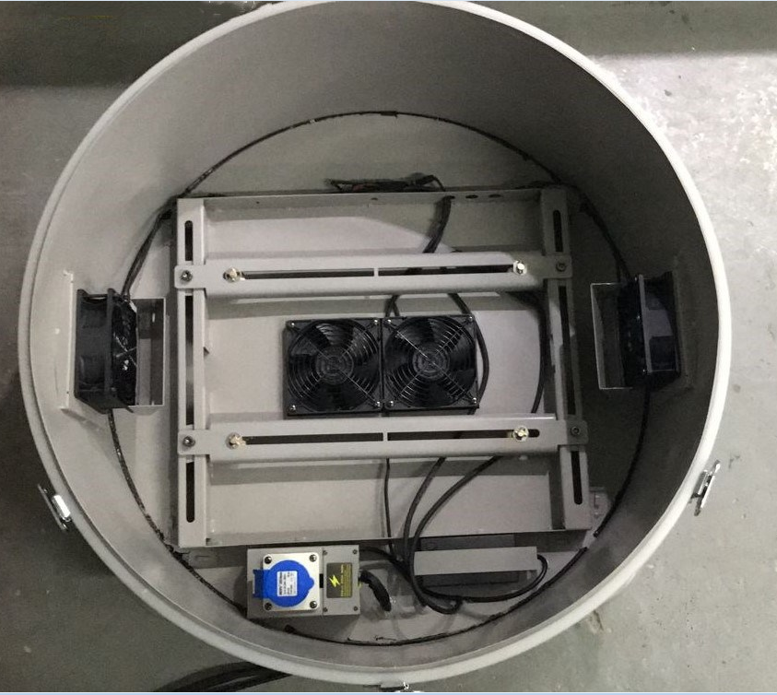
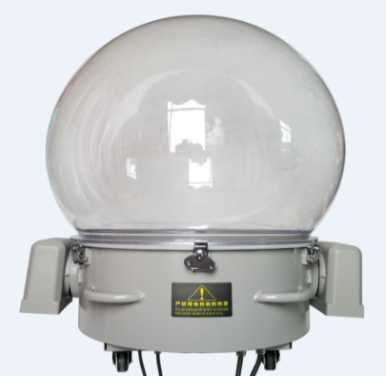

产品参数：
■电压范围：AC110V-240V
■工作环境温度(℃): -20°- 40°
■高: 1020mm
■透明罩直径：890mm；底座直径：730mm
■净重: 27KG
■IP指数: IP54
■灯具控制: DMX512
■安装方式:可以平放、侧挂，吊挂进出风弯管可以旋转至任意角度
■功能: 防雨,户外使用
■材质: 透明罩是美国进口的工程塑料制造而成，具有高透光性、抗紫外线、
不发黄、不易破裂等特性。
■信号及电源连接：配有两条2*0.3m²防水信号线和两条3*2.5m²防水电源线，
最大功率2500W.
■使用范围: 1000w-1500w光束灯或者其他类似体积的灯具。
■ voltage range:AC110V-240V
■Environment Working Temperature: -20°- 40°
■Height: 1020mm
■Rain cover diameter: 890mm； Base diameter: 730mm
■N/W: 27Kg
■Protection degree: IP54
■Control: DMX512
■Installation: Can be flat, side hanging, hanging, in and out of the wind pipe can
rotate to any angle.
■Function: Raining proof, for outdoor use
■Material: Transparent cover is made by the US imported engineering
plastics with high light penetration, anti-ultraviolet radiation, not
yellow, not easily broken.
■Signal And Power Connections: With two 2*0.3m²waterproof dmx cable and
two 3*2.5m² waterproof power line.,maximum power2500W.
■Suitable: 1000W-1500W beam lights and similar sized lights.

安装方案：
Installation:
1.底座板Base
2.将连接板两边的固定螺丝取下Take off the fixed screws on both sides of the connecting board.
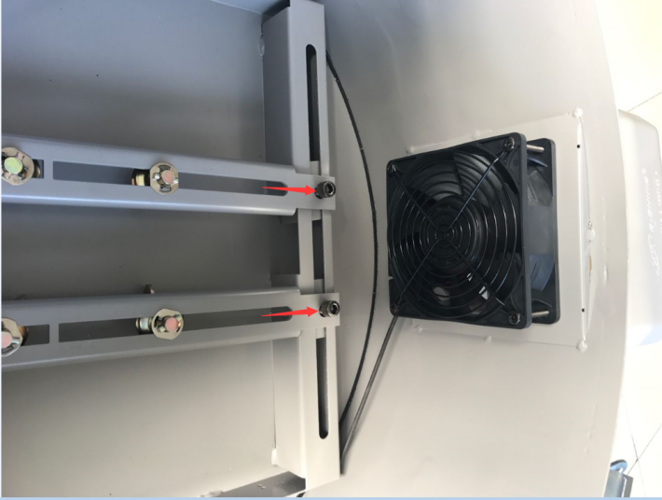

3.取出底座的连接板与灯具连接，根据灯具的大小位置调节，快速锁拧紧。Connect the board and light, and adjust it according to the light, then screw them tightly.
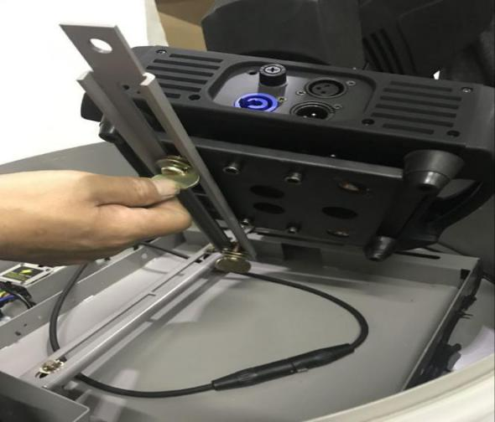
4.将灯具放置底座中，用原取下的螺丝固定连接
Put the connecting light and board on the base, and screaw-in the screaws have been taken off.
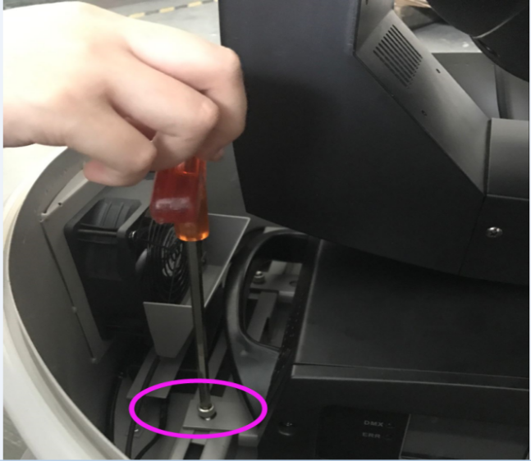

5.将透明罩与底座连接，用底座蝴蝶扣与透明罩固定
Put the cover on the base and fix it with the metal button on the base
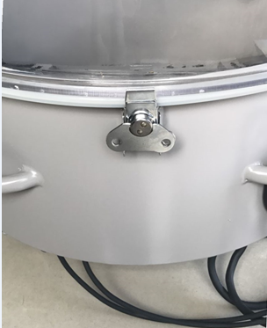
6.将配套通风弯口与底座连接Connect the tube on the base
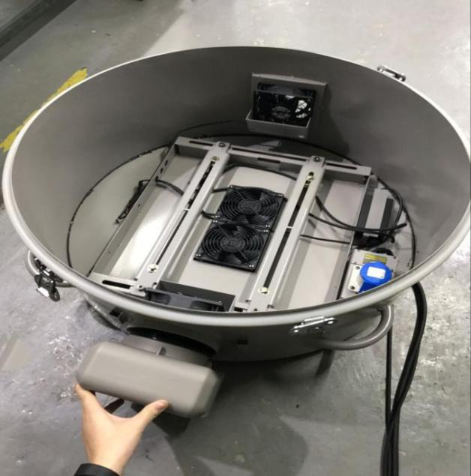

7.安全绳的连接Fasten the metal button and the tube
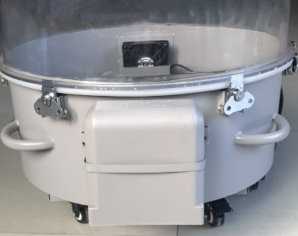

8.安装完毕Installation OK
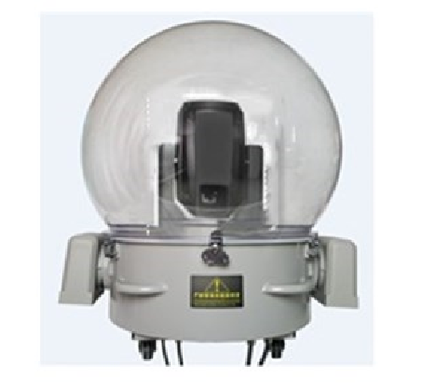

注意事项:Remark
1.透明罩上不能有任何遮挡物
There should be nothing cover the waterproof cover when in use.
2.严禁带电拆装
Do not disassemble the cover with electricity.
3.严禁遮挡进排风口，保留空间
Do not cover the exhaust outlet and keep some space.
4.进风口向下
The air inlet keeps downward.
5.进风口距离地面不小于50CM
The air inlet is not less than 50cm from the ground.
6.定时清理进风口过滤网
Regularly clean the air inlet filter.
7.确保装上防脱钢片
Make sure to install anti-off steel sheet.

